|  |  |
| --- | --- |
| **Assignment Case** |  |
| COMP6153  Operating System |
| **Computer Science** | **O213-COMP6153-SL07-01** |
| ***Valid on*** *Odd Semester Year 2020/2021* | **Revision 00** |

1. Seluruh mahasiswa tidak diperkenankan untuk:

*All students are not allowed to:*

* + 1. Melihat sebagian atau seluruh jawaban mahasiswa lain,

*Seeing a part or the whole answer from other student*

* + 1. Menyadur sebagian maupun seluruh jawaban dari buku,

*Adapted a part or the whole answer from the book*

* + 1. Mendownload sebagian maupun seluruh jawaban dari internet,

*Downloading a part or the whole answer from the internet,*

* + 1. Mengerjakan soal yang tidak sesuai dengan tema yang ada di soal,

*Working with another theme which is not in accordance with the existing theme in the matter of the case,*

* + 1. Melakukan tindakan kecurangan lainnya,

*Committing other dishonest actions,*

* + 1. Secara sengaja maupun tidak sengaja melakukan segala tindakan kelalaian yang menyebabkan hasil karyanya berhasil dicontek oleh orang lain / kelompok lain.

*Accidentally or intentionally conduct any failure action that cause the results of the project was copied by someone else / other groups.*

1. Jika mahasiswa terbukti melakukan tindakan seperti yang dijelaskan butir 1 di atas, maka **nilai mahasiswa** yang melakukan kecurangan (menyontek maupun dicontek) akan di – **NOL** – kan.

*If the student is proved to the actions described in point 1 above, the score of the student which committed dishonest acts (cheating or being cheated) will be “Zero”*

1. Perhatikan jadwal pengumpulan jawaban, segala jenis pengumpulan jawaban di luar jadwal tidak dilayani.

*Pay attention to the submission schedule, all kinds of submission outside the schedule will not be accepted*

1. Persentase penilaiaan untuk matakuliah ini adalah sebagai berikut:

*Marking percentage for this subject is described as follows:*

|  |  |  |
| --- | --- | --- |
| **Tugas Mandiri**  *Assignment* | **Proyek**  *Project* | **UAP**  *Final Exam* |
| 40% | - | 60% |

1. Software yang digunakan pada matakuliah ini adalah sebagai berikut:

*Software will be used in this subject are described as follows:*

|  |
| --- |
| **Software**  *Software* |
| VM Ubuntu Client 20.04  Java 8  Eclipse 2020.6  NachOS 5.0j |

## Ekstensi file yang harus disertakan dalam pengumpulan tugas mandiri dan uap untuk matakuliah ini adalah sebagai berikut:

*File extensions should be included in assignment and project collection for this subject are described as follows:*

|  |  |  |
| --- | --- | --- |
| **Tugas Mandiri**  *Assignment* | **Proyek**  *Project* | **UAP**  *Final Exam* |
| DOCX, JAVA, CLASS | - | JAVA, CLASS |

## Soal

*Case*

1. From the **home directory**, write a **command line** to create a directory based on the hierarchy below in a single execution!

<Home directory>

`-- monitor

|-- 19 inch

| |-- 60 Hz

| |-- 120 Hz

| |-- 144 Hz

|-- 24 inch

| |-- 60 Hz

| |-- 120 Hz

| |-- 144 Hz

1. From **Home**, write a **command line** to create a new file named **”GL HD TV”.txt** inside the **19 inch/60 Hz** folder, then **set permission** so the **owner** able to **read**, **write** and **execute** the **file**, while **groups** and **others are** only able to **read** and **execute** the file.
2. From **Home,** write a **command line** to **search file** inside the folder with the following criteria:

* **Inside 19 inch/60 Hz folder**
* **The types are .txt**
* **The filename is “GL HD TV”**

1. Write a **command line** to display **all processes** in **BSD** format, while **sorting the processes by CPU Utilization in descending order**.

**Java Programming**

**Monetorize**

**Monetorize** is a new screen department store in Indonesia. As a programmer, you are asked to create a program to handle customer orders.

Here are the detail requirements of the application:

* The application use **Object Oriented Programming** concept and **Inheritance**
* Create methods to calculate the **Price**
* When the **program starts**, ask the user to **input the type of screen**. Validate the inputted menu must be between “**Monitor**” and “**TV**”(**case insensitive**).



**Figure 1. Screenshot of Adding Order**

* If user input **Monitor** on the menu, then:
* Ask the user to input **Name**. Validate the **Name** must be between **5** and **20 characters**
* Ask the user to input **Type**. Validate the **Type** must be between “**LCD”**, and “**LED”** (**case** **sensitive**).
* Ask the user to input **Resolution**. Validate the **Resolution** must be between “**720p”**, “**1080p**” and “**4K**” (**case** **insensitive**).
* Ask the user to input the **Screen Refresh Rate**. Validate the **Screen Refresh Rate** must be **multiple of 60** and **not zero**.

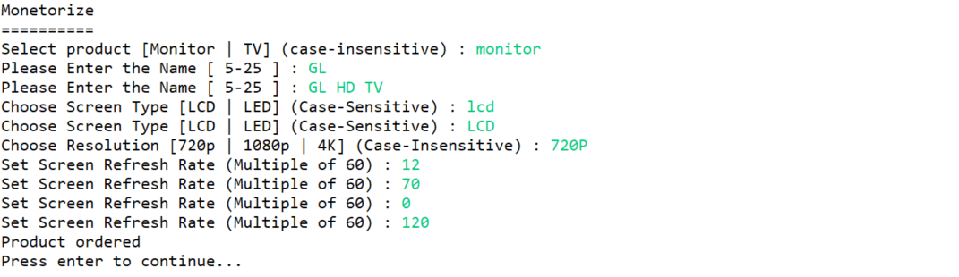

**Figure 2. Screenshot of Input Monitor Order**

* Determine the **Price** based on the following rules:

|  |  |
| --- | --- |
| **Type** | **Type Price** |
| LCD | 1.000.000 |
| LED | 3.000.000 |

|  |  |
| --- | --- |
| **Resolution** | **Resolution Price** |
| 720p | 500.000 |
| 1080p | 1.000.000 |
| 4K | 1.500.000 |

**Refresh Rate Price = (Refresh Rate / 60) * 250.000**

**Price = Type Price + Resolution Price + Refresh Rate Price**

* Display **Name**, **Type**, **Resolution**, **Refresh Rate** and **Price** of the inputted order

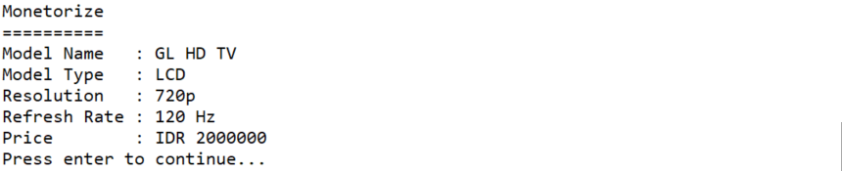

**Figure 3. Screenshot of View Monitor Order**

* If user input **TV** on the menu, then:
* Ask the user to input **Name**. Validate the **Name** must be between **5** and **20 characters**
* Ask the user to input **Type**. Validate the **Type** must be between “**LCD”**, and “**LED”** (**case** **sensitive**).
* Ask the user to input **Resolution**. Validate the **Resolution** must be between “**720p”**, “**1080p**” and “**4K**” (**case** **insensitive**).
* Ask the user to input the **Screen Refresh Rate**. Validate the **Screen Refresh Rate** must be **multiple of 60** and **not zero**.
* Ask the user to input the **Number of Channels.** Validate the **Number of Channels** must **more** **than** **equals** to **10.**

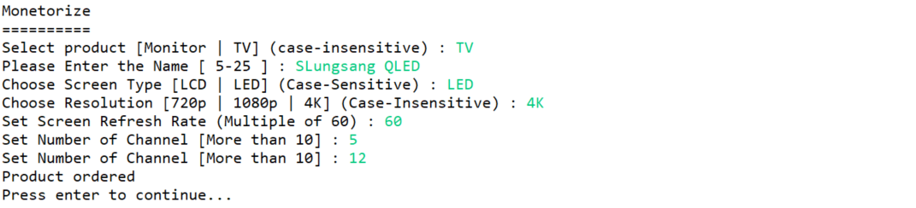

**Figure 4. Screenshot of Input TV Order**

* Then, calculate the **Price** with the following rules:

|  |  |
| --- | --- |
| **Type** | **Type Price** |
| LCD | 1.000.000 |
| LED | 3.000.000 |

|  |  |
| --- | --- |
| **Resolution** | **Resolution Price** |
| 720p | 500.000 |
| 1080p | 1.000.000 |
| 4K | 1.500.000 |

**Refresh Rate Price** **= (Refresh Rate / 60) * 250.000**

**Channel Price = Channel * 10.000**

**Price** = Type Price + Resolution Price + Refresh Rate Price + Channel Price

* Display **Name**, **Type**, **Resolution**, **Refresh Rate**, **Number of Channel** and **Price** of the inputted order

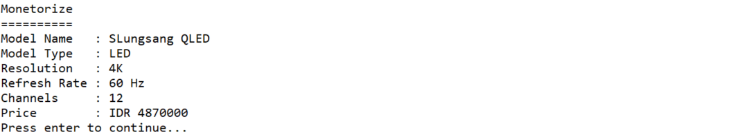

**Figure 5. Screenshot of View TV Order**